Experiment No. – 2
Date of Performance: | 22/7/2025
Date of Submission: | 29/7/2025
Program Execution/  formation/  correction/  ethical practices  (06) | Timely  Submission  (01) | Viva  (03) | Experiment  Total (10) | Sign with Date

Experiment No. 2
Data cleaning operations on a dataset in cognitive application.

1.1 Aim: Implementation of data cleaning operations on dataset in Cognitive Application.

1.2 Course Outcome: Understand uncertainty processes and cognitive computations
and applications.

1.3 Learning Objectives: Explore use cases of Cognitive Computing

1.4 Requirement: Python (Google Colab), Dataset Used: Kaggle

1.5 Related Theory:

Cognitive Computing.
Cognitive computing is the use of computerized models to simulate the human thought process in complex situations where the answers might be ambiguous and uncertain. The phrase is closely associated with IBM's cognitive computer system. Computers are faster than humans at processing and calculating, but they've yet to master some tasks, such as understanding natural language and recognizing objects in an image. Cognitive computing is an attempt to have computers mimic the way the human brain works. Systems used in the cognitive sciences combine data from various sources while weighing context and conflicting evidence to suggest the best possible answers. To achieve this,cognitive systems include self- learning technologies that use data mining, pattern recognition and NLP to mimic human intelligence.Cognitive computing uses these processes in conjunction with self-learning algorithms, data analysis and pattern recognition to teach computing systems. The learning technology can be used for sentiment analysis, risk assessments and face detection. In addition, cognitive computing is particularly useful in fields such as healthcare, banking, finance and retail.
To achieve those capabilities, cognitive computing systems must have the following attributes:
Adaptive. Systems must be flexible enough to learn as information changes and goals evolve. They must digest dynamic data in real time and adjust as the data and environments change.

Interactive. Human-computer interaction is a critical component in cognitive systems. Users must be able to interact with cognitive machines and define their needs as they change. The technologies must also be able to interact with other processors, devices and cloud platforms.

Iterative and stateful. Cognitive computing technologies can ask questions and pull in additional data to identify or clarify a problem. They must be stateful in that they keep information about similar situations that have occurred previously.

Contextual. Understanding context is critical in thought processes. Cognitive systems must understand, identify and mine contextual data, such as syntax, time, location, domain, user requirements, user profiles, tasks and goals. The systems can draw on multiple sources of information, including structured and unstructured data and visual, auditory and sensor data.

1.6 Procedure:

Create one cognitive application.

1.7 Program and Output:



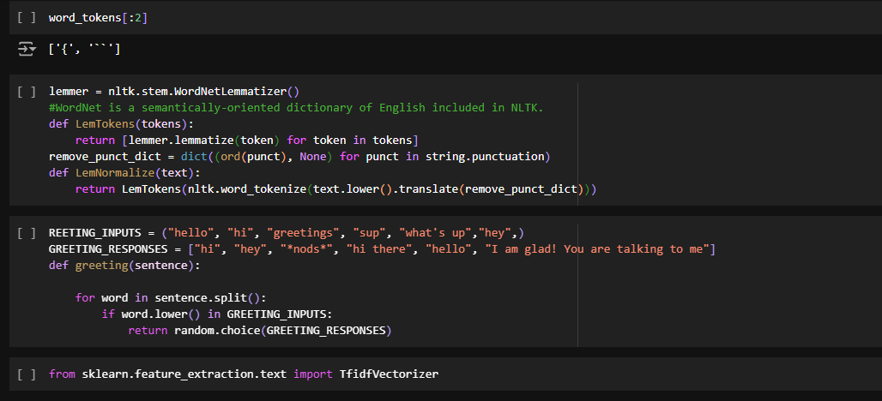

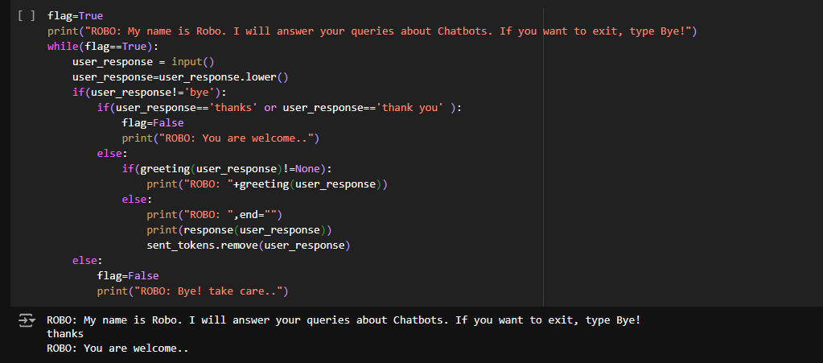

1.8 Conclusion:
In this experiment, various data cleaning operations were applied to a dataset in the context of a cognitive application. Cleaning the data ensured that the dataset was free from missing values, duplicates, outliers, noise, and inconsistencies, which improves the overall performance of the cognitive models. By using Python libraries like pandas and numpy, the data was preprocessed efficiently, making it suitable for use in AI and machine learning models. Clean data is fundamental to the success of cognitive applications, as it leads to more accurate results and better decision-making.

1.9 Questions:

1. Explain Cognitive Computing.
Ans: Cognitive computing refers to technology platforms that simulate human thought processes in a computerized model. It aims to mimic how the human brain works by using artificial intelligence (AI) techniques, including machine learning, natural language processing, neural networks, and reasoning algorithms. The goal is to create systems that can understand, learn, and reason, helping to solve complex problems and make better decisions in a human-like manner.
Unlike traditional computing, which relies on pre-defined rules and algorithms, cognitive computing systems continuously learn and adapt based on new data. They can process vast amounts of unstructured information, such as text, images, and speech, and derive insights from it. Applications include personalized healthcare, financial analysis, customer service, and decision-making in various fields. Cognitive computing aims to augment human intelligence rather than replace it, enabling humans and machines to collaborate more effectively.

2.Explain the one application based on cognitive computing.
Ans: One prominent application of cognitive computing is in personalized healthcare, particularly in diagnosing and treating diseases. Cognitive computing systems, such as IBM Watson Health, can analyze vast amounts of medical data, including patient records, clinical studies, medical literature, and diagnostic images. By processing this unstructured information, the system can assist doctors in diagnosing conditions, identifying potential treatment options, and predicting patient outcomes.

For instance, in cancer treatment, cognitive computing can analyze a patient's medical history, genetic information, and tumor characteristics to suggest the most effective treatment plans. It can compare the patient’s data against thousands of research studies and clinical trial results to recommend personalized therapies that have the highest probability of success. The system continually learns from new cases and medical advancements, improving its recommendations over time.

This application helps doctors make more informed decisions, potentially increasing treatment success rates and reducing trial-and-error approaches in healthcare. By augmenting human expertise, cognitive computing in personalized healthcare leads to better patient outcomes and more efficient care delivery.

3.Explain the advantages of cognitive computing.
Ans:
- Enhanced Decision-Making: It provides valuable insights by analyzing large amounts of data, aiding better and more informed decisions.
- Continuous Learning: Systems adapt and improve over time by learning from new data and experiences.
- Increased Efficiency: Automates complex and repetitive tasks, freeing up human workers for higher-value activities.
- Handling Unstructured Data: Excels at processing text, images, and other unstructured information, unlike traditional systems.
- Personalization: Enables tailored experiences by adapting services to individual preferences and behaviors.

